**1.**

Introduction:

An electronic portfolio (also known as an eportfolio, e-portfolio, digital portfolio, or online portfolio)[1] is a collection of electronic evidence assembled and managed by a user, usually on the Web. Such electronic evidence may include input text, electronic files, images, multimedia, blog entries, and hyperlinks. E-portfolios are both demonstrations of the user's abilities and platforms for self-expression. If they are online, users can maintain them dynamically over time.

一个电子档案袋（也称为数字档案袋或在线档案袋）是由用户（通常在网络上）组合和管理的电子证据的集合。 这样的电子证据可以包括输入文本，电子文件，图像，多媒体，博客和超链接。 电子档案袋既是用户能力的体现，也是用户自我表达的平台。用户可以随时间动态保持自己的电子档案。

One can regard an e-portfolio as a type of learning record that provides actual evidence of achievement. Learning records are closely related to the learning plan, an emerging tool which individuals, teams, communities of interest, and organizations use to manage learning.[citation needed] To the extent that a personal learning environment captures and displays a learning record, it may also operate as an electronic portfolio.

人们可以将电子档案袋视为一种提供成就的实际证据的学习记录。 学习记录与学习计划密切相关，学习计划是个人，团队，感兴趣的社区和组织用来管理学习的新兴工具。从某种意义上来说，通过一个人的学习环境是可以捕获这个人的学习记录的，这也是我们这个电子档案管理系统的一种行为方式。

E-portfolios, like traditional portfolios, can facilitate students' reflection on their own learning, leading to more awareness of learning strategies and needs.[2] Comparative research by M. van Wesel and A. Prop between paper-based portfolios and electronic portfolios in the same setting tentatively suggests that use of an electronic portfolio may lead to better learning outcomes.[3]

就像传统的档案袋一样，电子档案袋可以帮助学生进行学习上的反思，从而改进自己的学习策略和增强学习的意识。国外专家M. van Wesel和A.Prop基于纸质的档案袋和电子档案袋之间的比较研究初步表明，使用电子档案袋令学生取得了更好的学习成果。

Types:

There are three main types of e-portfolios, although they may be referred to using different terms:

1. developmental (e.g., working)
2. assessment
3. showcase

电子档案袋的类型有很多的表达术语，在国外主要将电子档案袋的类型分为以下3种：

（1）发展型（也可以表达为工作）

（2）评估型

（3）展示型

A developmental e-portfolio can show the advancement of skill over a period of time rubrics. The main purpose is to provide an avenue for communication between student and instructor. An assessment portfolio will demonstrate skill and competence in a particular domain or area. A showcase portfolio highlights stellar work in a specific area, it is typically shown to potential employers to gain employment. When it is used for job application it is sometimes called career portfolio. Most e-portfolios are a mix of the three main types to create a hybrid portfolio.

发展型的电子档案袋可以显示一个人在一段时间内综合技能的进步。 主要目的是为学生和教师之间的沟通提供一条途径。

评估型的电子档案袋将展示在特定专业或领域的技能和能力。

展示型的电子档案袋则突出了在特定领域的出色工作，通常用以向潜在雇主展示获得就业机会。 当它用于工作申请时，有时被称为事业型的电子档案袋。

大多数的电子档案袋都是这三种主要类型的混合，以此创建一个混合型的电子档案袋。

Usage:

Today, electronic portfolios are gaining popularity in:

1. Schools (see also Technology integration)
2. Higher education
3. Continuing professional development
4. Job applications/professional advertisements
5. Therapy groups
6. Assessment
7. Accreditation
8. Recognition of prior learning (RPL)

今天，电子档案袋在以下领域范围越来越受欢迎：

（1）学校（技术一体化）

（2）高等教育

（3）持续专业发展

（4）工作申请/专业广告

（5）治疗

（6）评估

（7）认证

（8）先验学习（外国的一种说法，Recognition of prior learning，简称RPL）

**In education:**

In education, the electronic portfolio is a collection of a students' work that can advance learning by providing a way for them to organize, archive, and display work. The electronic format allows an instructor to evaluate student portfolios via the Internet, CD-ROM, DVD, or zip disk. Electronic portfolios have become a popular alternative to paper-based portfolios because they provide the opportunity to review, communicate and give feedback in an asynchronous manner. In addition, students are able to reflect on their work, which makes the experience of creating the e-portfolio meaningful. A student e-portfolio may be shared with a prospective employer or used to record the achievement of program or course specific learning outcomes.[4]

在教育方面，电子档案袋是一种学生学习情况的收集，可以通过为他们提供一种组织，存档和展示工作的方式来促进学习。电子档案袋的电子格式允许教师通过互联网，CD-ROM，DVD或zip盘来评估学生的学习情况。电子档案袋已经成为基于纸质档案袋的流行替代品，因为它们提供以异步方式审查，交流和提供反馈的机会。 此外，学生能够反思他们的学习，这使得电子档案袋的创建更有意义。学生电子档案袋可以与潜在雇主分享，向潜在雇主展示，或用于记录课程与课程特定的学习成果。

The uses of e-portfolios are most common in the courses with departments of education. Most preservice teachers are asked to compile an e-portfolio to demonstrate competencies needed to gain teaching certification or licensure. Student e-portfolios are increasingly being used in other disciplines such as communications, math, business, nursing, engineering and architecture. In education e-portfolios have six major functions:

1. Document skills and learning;
2. Record and track development within a program;
3. Plan educational programs;
4. Evaluate and monitor performance;
5. Evaluate a course;
6. Find a job

电子档案袋的用途在教育部门的课程中最能体现。大多数职业教师被要求以电子档案袋来证明获得教学认证或执照所需的能力。 学生的电子档案越来越多地被用于其他学科，如通信，数学，商业，护理，工程和建筑学。在教育上，电子档案袋有六个主要功能：

（1）记录技能和学习;

（2）记录和跟踪程序内的开发;

（3）计划教育方案;

（4）评估和监测绩效;

（5）评价课程;

（6）找工作

In general e-portfolios promote critical thinking and support the development of technology literacy skills. Faculty now use e-portfolios to record course or discipline designs that may be shared with colleagues to promote teaching and learning. A teaching e-portfolio is used to showcase career accomplishments.[4]

总的来说，电子档案袋能够促进批判性思维，支持技术素养技能的发展。 教师现在使用电子档案袋记录课程或纪律违规，并且可以与同事分享，以促进教学和学习。 教学型电子档案袋用于展示职业成就。

E-portfolios also help to foster an independent and autonomous way of thinking, according to Strivens.[5] This is in large part because people must focus on their collective work, think about how it will be portrayed, and what the work says about them as an individual. The individual is then in charge of their learning and the choice of where to demonstrate their proficiency. People are also forced to reflect on what they have learned and how they plan to build and improve in the future. This helps people to become better critical thinkers and helps them to develop their writing and multimedia skills. Today, many students are using multimedia such as Facebook, Twitter, and texting—all informal settings. The electronic portfolio, on the other hand, is a more formal setting where students must apply both their knowledge of how the web works and the message they want to convey. In this sense, students' use and comfort with the web at times can he a hindrance if they are not taught to use electronic portfolios in the correct fashion, suggests Lane.[6] Many universities and schools are currently working to make sure that students are gaining practice and experience with electronic portfolios so that they are able to use them to the best of their ability. For example, in places like Michigan students can earn the MCOATT (Michigan Certificate of Outstanding Achievement in Teaching Technology) for submitting an electronic portfolio which demonstrates evidence of technology being used in the classroom.[7] This consortium is an organization aimed to make Michigan one of the leaders in integrating technology into the training of young professionals.

国外学者Strivens曾说过，电子档案袋也有助于培养一种独立和自主的思维方式。这在很大程度上是因为人们必须专注于他们的集体档案，思考如何描述一个电子档案，以及电子档案对他们作为一个个体的描述。每个人都要为自己的学习负责，并且选择展示自己学习技能和学习成就的方式。使用我们这个电子档案管理系统，人们也被迫反思他们所学到的东西，以及如何计划与建设自己的未来。这有助于人们成为更好的批判性思维者，并帮助他们发展自己的阅读、写作和多媒体技能。今天，许多学生使用多媒体，如QQ、微信、微博，这些都不是一个正式的环境。而电子档案管理系统则是一个更正式的环境，学生必须应用他们对网络工作的知识和他们想传达的信息。在这个意义上，如果不教导学生以正确的方式使用电子档案袋，学生对网络的使用和舒适度有时会受到阻碍。在国外，许多大学和学校目前正在努力确保学生获得电子档案袋的实践和经验，以便他们能够最大限度地利用他们的能力。例如，在密歇根州这样的地方，学生可以获得MCOATT（密歇根教学技术杰出成就证书），提交一个电子作品集，证明教室使用了技术。这个联盟是一个旨在使密歇根州成为将技术融入年轻专业人员培训领导者的组织。

**Other Uses:**

Some e-portfolio applications permit varying degrees of audience access, so the same portfolio might be used for multiple purposes. According to Anderson, e-portfolios can then go viral and be passed on to be easily viewed by many on the web.[8][full citation needed]

其它用途：

一些电子档案袋允许不同程度的观众访问，因此同样的电子档案袋可以用于多种目的。国外学者Anderson就有这么一个说法，电子档案袋可以像病毒一样传播并传递，以便很多人在网上查看。

References:

1. ^ Zimmerman, Eilene (30 June 2012). "Career couch: Showcasing Your Work, in an Online Portfolio". New York Times. Retrieved 7 June 2014.

2. Jump up ^ Moon, Jenny. "Guide for Busy Academics No. 4: Learning through reflection". The Higher Education Academy. Retrieved 7 June 2014.

3. Jump up ^ M. van Wesel & A. Prop (2008). "The influence of Portfolio media on student perceptions and learning outcomes" (PDF). Maastricht University. Archived from the original (PDF) on February 29, 2012.

4. ^ Jump up to: a b Lorenzo, George; Ittelson, John (2005). "An Overview of E-Portfolios" (PDF). Educause. Archived from the original (PDF) on 2 November 2013. Retrieved 7 June 2014.

5. Jump up ^ Strivens, Janet (February 2007). "A survey of e-pdp and e-portfolio practice in UK Higher Education" (PDF). Higher Education Academy. Retrieved 7 June 2014.

6. Jump up ^ Lane, C. (2007). "The Power of 'e': Using e- Portfolios to Build Online Presentation Skills". Innovate. 3 (3): 5.

7. Jump up ^ Consortium for Outstanding Achievement in Teaching with Technology (2009). "COATT: Preparing Teachers for the Evolving Classroom".

8. Jump up ^ Anderson, C. (2010) TED: Ideas Worth Spreading.

Haag, S., Cummings, M., McCubbrey, D., Pinsonneault, A., Donovan, R. (2006). Management Information Systems for the Information Age. Building an E-portfolio(XLM-J). Toronto: Mcgraw-Hill. ISBN 0-07-095569-7.

Hebert, Elizabeth A., (2001) The Power of Portfolios - What children can teach us about Learning and Assessment. San Francisco: Jossey-Bass. ISBN 0-7879-5871-9.

Mendoza-Calderón, Marco A.; Ramirez-Buentello, Joaquin. (2006). Handbook of Research on ePortfolios. Facilitating Reflection Through ePortfolio at Tecnológico de Monterrey. Hershey, USA. Ali Jafari (Ed). pp: 484-493 ISBN 1-59140-890-3.

Wiedemann, Julius, ed. (2008). Web Design: Flashfolios. Icons. Hong Kong; Köln; London; Los Angeles; Madrid; Paris; Tokyo: Taschen. ISBN 978-3-8365-0498-0. OCLC 449678340.

Richardson, W. (2010). Blogs, wikis, podcasts, and other powerful web tools for classrooms. (3 ed., pp. 23, 151-153). Thousand Oaks, CA: Corwin.

"Effective Practice with e-Portfolios. Supporting 21st century learning" (PDF). JISC. 2008.

**2.**

**What is an ePortfolio?**

An ePortfolio (electronic portfolio) is an electronic collection of evidence that shows your learning journey over time. Portfolios can relate to specific academic fields or your lifelong learning. Evidence may include writing samples, photos, videos, research projects, observations by mentors and peers, and/or reflective thinking. The key aspect of an eportfolio is your reflection on the evidence, such as why it was chosen and what you learned from the process of developing your eportfolio. (Adapted from Philippa Butler’s “Review of the Literature on Portfolios and Eportfolios” (2006), page 2.)

电子档案袋是什么？

电子档案袋是一个电子收集证据，会随着时间的推移记录您的学习旅程。电子档案袋可以涉及特定的学术领域或您的终身学习。证据可能包括写样本，照片，视频，研究项目，导师和同伴的观察，和/或反思思维。电子档案袋的关键方面是你对证据的反思，例如为什么选择电子档案袋，以及从开发电子档案袋的过程中学到了什么。

An ePortfolio is not a specific software package, but more a combination of process (a series of activities) and product (the end result of the ePortfolio process). Presentation portfolios can be created using a variety of tools, both computer desktop tools and online (Barrett, 2000; Barrett, 2004-2008). Most commercial ePortfolio tools are focused on the product (right-hand) side of the diagram below, although some open source tools contain some of the Web 2.0-type tools that enhance the process (left-hand) side of the diagram, such as blogs, social networking, and RSS feeds.

电子档案袋不是特定的软件包，而是更多的过程（一系列活动）和产品（电子档案袋过程的最终结果）的组合。 可以使用各种工具，计算机桌面工具和在线创建演示文稿组合（Barrett，2000; Barrett，2004-2008）。 大多数商业电子公文包工具集中在下图的产品（右侧）侧，尽管一些开源工具包含一些Web 2.0类型的工具，可以增强图表的进程（左侧），例如 博客，社交网络和RSS订阅源。

The real value of an e-portfolio is in the reflection and learning that is documented therein, not just the collection of work. In fact, here are two of my favorite quotes from a book and a resource created by JISC in the UK:

电子档案袋的真正价值在于其中记录的反思和学习，而不仅仅是工作的收集。 事实上，这里是我最喜欢的一本书的报价和英国的JISC创造的资源：

"The overarching purpose of portfolios is to create a sense of personal ownership over one's accomplishments, because ownership engenders feelings of pride, responsibility, and dedication." (p.10) - Paris & Ayres. (1994) .

外国学者Paris＆Ayres 说过：“电子档案袋的首要目的是创造了一个人的成就个人的主人翁意识，因为所有权滋生自豪感，责任感和奉献精神的感觉。”

"The e-portfolio is the central .and common point for the student experience. It is a reflection of the student as a person undergoing continuous personal development, .not just a store of evidence.".. (Geoff Rebbeck, e-Learning Coordinator, Thanet College, quoted in JISC, 2008)

“电子档案袋是学生体验的中心和共同点，它反映了学生作为一个持续个人发展的人，而不仅仅是一个证据库。”（Geoff Rebbeck，电子学习 协调员，Thanet学院，2008年在监委会引用）

**What is a blog? What is a wiki? How are these tools used in ePortfolios?**

A web log, or blog, is an online journal that encourages communication of ideas, and individual entries are usually displayed in reverse-chronological order. Blogs were one of the first Web.2.0 tools, built on an architecture of interaction, allowing subscribing through RSS feeds, and feedback in the form of comments on specific entries. Blogs provide an ideal tool to construct learning journals, as discussed by Crichton and Kopp (2008) from the University of Calgary. Their research suggests:

什么是博客？ 什么是wiki？ 这些工具如何在电子档案袋中使用？  
网络日志或博客是一个鼓励思想交流的在线日志，并且个人条目通常按逆时间顺序显示。 博客是第一个基于互动体系结构的Web.2.0工具之一，允许通过RSS订阅订阅，以及对特定条目发表评论的反馈。 博客提供了构建学习期刊的理想工具，如来自卡尔加里大学的Crichton和Kopp（2008）所讨论的。 他们的研究表明：

... that eJournals help to make ePortfolios more authentic and relevant to the students’ lives. Focusing on reflection and inquiry, [their] study explored the use of social software as a tool to build and sustain a community of practice, recognizing that teacher education lives in a community well beyond the university experience. (p. 2)

电子期刊有助于使电子档案袋更真实和相关的学生的生活。 [他们的]研究侧重于反思和探究，探讨了使用社会软件作为建立和维持实践社区的工具，认识到教师教育生活在一个超出大学经验的社区。

According to Wikipedia, "A wiki is a collection of Web pages designed to enable anyone with access to contribute or modify content, using a simplified markup language. Wikis are often used to create collaborative websites and to power community websites. The collaborative encyclopedia Wikipedia is one of the best-known wikis." (The first developer of wiki software named it after the WikiWiki Shuttle in the Honolulu airport, because wiki meant quick in Hawaiian.) A wiki tool, such as Google Sites, can be used to construct hyperlinked web pages, organized thematically.

根据维基百科，“维基是一个网页的集合，旨在使任何人都可以使用简化的标记语言来贡献或修改内容。维基经常用于创建协作网站和支持社区网站。 一个最着名的维基百科。 （wiki软件的第一个开发者，在檀香山机场的WikiWiki Shuttle之后命名它，因为wiki意味着在夏威夷的快速）。一个wiki工具，如Google Sites，可以用来构建超链接的网页，组织主题。

This story points out the challenges we have in the implementation of ePortfolios in education: the tension between what I call the "two different faces" of ePortfolios. I am promoting the concept of two portfolios: the Working Portfolio, which WSU calls the "workspace" or some schools have called the [digital] shoebox; and any number of Presentation Portfolios (depending on purpose and audience) which WSU calls the "showcase" and schools call "showtime!" In order to build more formal presentations, we need the digital archive or the storage of work samples (collection) to draw upon (selection) for inclusion in these presentations.

我们在教育中实施电子档案袋的挑战：我称之为“两种不同的面孔”之间的紧张关系。 我推广两个电子档案袋的概念：工作型电子档案袋，WSU称之为“工作区”或一些学校称为[数字]鞋盒; 和任何数量的展示型电子档案袋（根据目的和观众），WSU称为“展示”和学校叫“showtime！ 为了建立更加正式的演示，我们需要数字档案或工作样本（收集）的存储来利用（选择）包含在这些演示中。

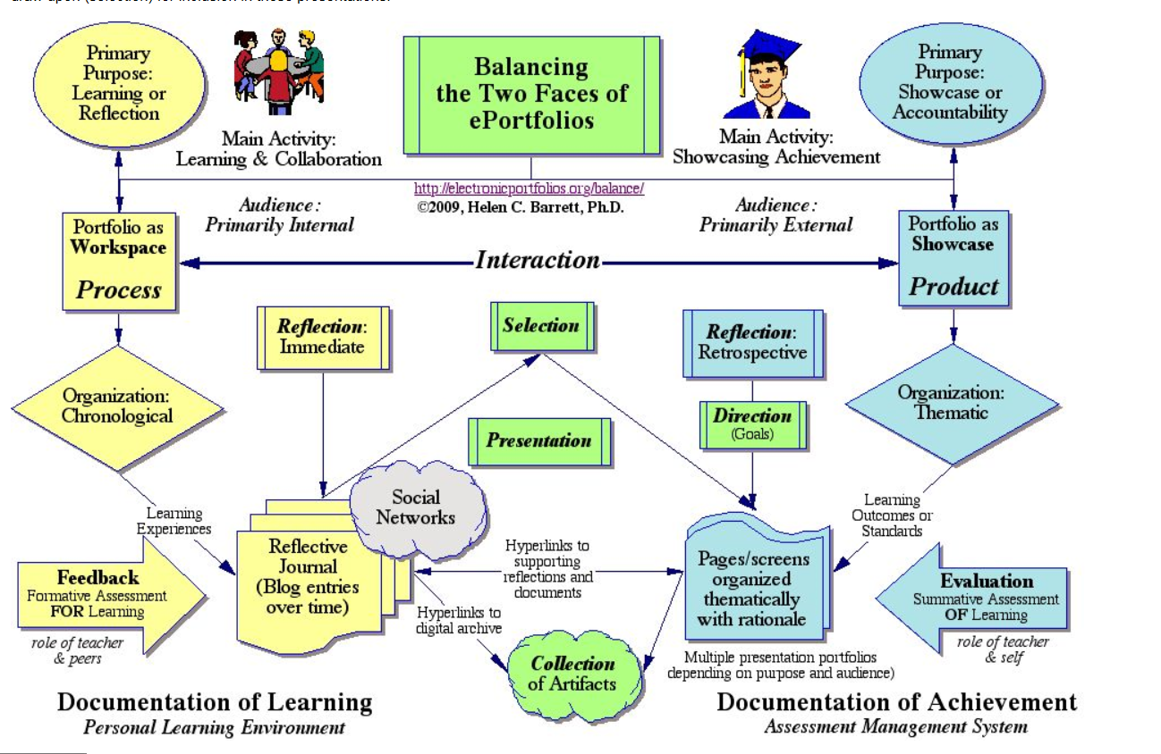

**3. Boston University:**

Why Use ePortfolio?

1. Window into student’s mind
2. Cutting-edge research
3. 21-Century learning skills
4. Compete in the global research market
5. Make learning visible (Grad School Application, Land a Job, Journal, History of Work)

为什么使用电子档案袋？

（1）进入学生的脑海  
（2）前沿研究  
（3）21世纪的学习技能  
（4）在全球研究市场竞争  
（5）使学习可见（研究生应用，工作，日记，工作历史）

How do we use ePortfolio?

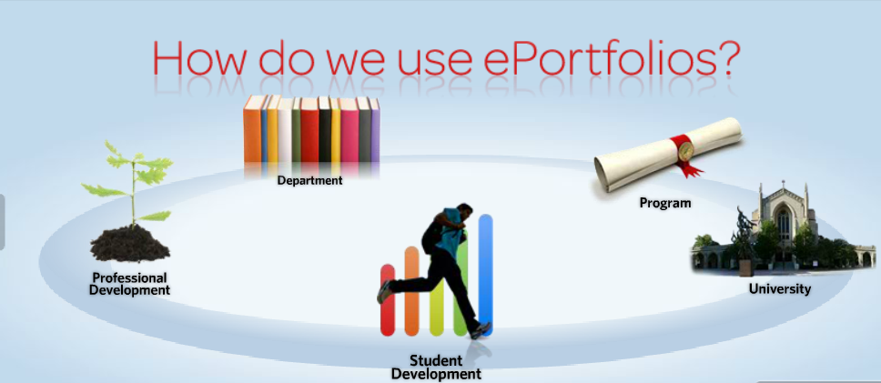

Who’s Using ePortfolio?

1. School of Public Health
2. College of Communication
3. School of Education
4. Music History
5. Writing Program(Faculty)
6. Writing Program(Student)

谁在用电子档案袋？

（1）公共卫生学院  
（2）交通学院  
（3）教育学院  
（4）音乐史  
（5）写作计划（教师）  
（6）写作计划（学生）

Summarize the flow/what it does:

Create, Collect, Select, Reflect, &Connect(可具体形容我们网站是怎么做的，每个动作是怎么实现的)

总结流程/功能：

创建，收集，选择，反映和连接（可具体形容我们网站是怎么做的，每个动作是怎么实现的）

**4.**

An electronic portfolio or ePortfolio is a generic term encompassing as wide a range of types and products as there are reasons for using them. The simplest starting point is to consider an ePortfolio as an extension of the paper based-portfolio, bringing with it the obvious benefit of making a portfolio of evidence portable and shareable anywhere that you have Internet access – "the new generation of the three ring binder" JISC My World Project Final Report, Roberts. 2006

电子档案袋是一个通用术语，涵盖广泛的类型和产品，因为有使用它们的原因。 最简单的出发点是将电子档案袋视为基于纸张的投资组合的扩展，带来明显的好处，使得证据组合在您上网的任何地方都是可移植的和可共享的 - “新一代三环活页夹 “JISC我的世界项目最终报告，罗伯茨。 2006年。

In fact, an ePortfolio has a much broader scope as an online collection of reflections and digital Artefacts (such as documents, images, blogs, resumés, multimedia, hyperlinks and contact information). Learners and staff can use an ePortfolio to demonstrate their learning, skills and development and record their achievements over time to a selected audience.

事实上，电子档案袋具有更广泛的范围，作为反射和数字文物（例如文档，图像，博客，简历，多媒体，超链接和联系信息）的在线集合。 学习者和工作人员可以使用电子档案袋来展示他们的学习，技能和发展，并将他们的成就随时间记录到选定的受众。

"ePortfolios ... are personal online spaces for students to access services and store work. They will become ever more useful as learners grow up and start moving between different types of learning and different institutions" Secretary of State for Education and Skills, UK, January 2006.

“电子档案袋是学生获得服务和存储工作的个人在线空间，随着学习者成长并开始在不同类型的学习和不同机构之间移动，它们将变得更加有用”。英国教育和技能国务秘书， 2006年1月。

They have the potential to provide a central, linking role between the more rigid, institution-led learning management system and the learners’ social online spaces.

他们有可能在更加严格的，以制度为主导的学习管理系统和学习者的社交网络空间之间提供中心的联系作用。

There are sound applications for the learner, the teacher, the institution – and sometimes combinations of the three. A teacher and learner for example can be one and the same person, with differing requirements from the same ePortfolio. It can be used to create collections of artefacts to share with fellow students, peers, family and friends, to present to potential employers and to complement applications for research funding. In short, it is an online space from which to manage your life, learning and goals.

有学习者，老师，机构的声音应用程序 - 有时三者的组合。 例如，教师和学习者可以是同一个人，对同一个电子档案袋具有不同的要求。 它可以用于创建文物集合，与同学，同学，家人和朋友分享，向潜在雇主展示并补充研究资金申请。 总之，它是一个在线空间，从中管理你的生活，学习和目标。

**Learning - Reflective learning, personalized learning, lifelong learning**

An ePortfolio is an ideal tool for meeting the needs of established and emerging pedagogy and approaches to learning.

学习 - 反思学习，个性化学习，终身学习  
电子档案袋是满足既定和新兴教育学和学习方法需求的理想工具。

Reflective learning is "..a form of mental processing that we use to fulfil a purpose or to achieve some anticipated outcome. It is applied to gain a better understanding of relatively complicated or unstructured ideas" HE Academy Guides for busy academics, no 4, Moon 2005

反思学习是“精神处理的一种形式，我们用来实现一个目的或实现一些预期的结果。它用于更好地理解相对复杂或非结构化的想法”HE Academy Guides for busy academics，no 4， Moon 2005

An ePorfolio allows for building in reflective activities for learners and staff, through blog functions and the creation of 'Critical incident diaries' in which users reflect on their learning and experiences over a given period or activity. For example, this could be reflections on how a student dealt with a problem, or processed some new information on a given topic. This can become a two way process with a tutor or peer providing feedback via the same diary.

电子档案袋允许通过博客功能和创建“关键事件日志”来为学习者和员工构建反思活动，用户可以在其中反映他们在特定时期或活动中的学习和体验。 例如，这可以是学生如何处理问题的反思，或处理关于给定主题的一些新信息。 这可以成为一个双向过程，导师或同事通过相同的日记提供反馈。

It works as a user-centred, personalised learning space allowing the user to shape the way they present themselves to the world. Content and layout can be personalised to create multiple Views which meet the specific, differing or changing requirements of the user. This ties in with one of the key tenets of personalised learning, that students become key partners in the design of learning to suit their needs.

它作为一个以用户为中心的个性化学习空间，允许用户塑造他们向世界展示自己的方式。 内容和布局可以被个性化以创建满足用户的特定，不同或变化的需求的多个视图。 这与个性化学习的关键原则之一相关，学生成为学习设计中的关键合作伙伴，以满足他们的需求。

"Personalising learning involves thinking about knowledge as an active process. Students get to be informed, active participants in their own learning, they contribute to decisions about what learning can work best for them, and they have a much better understanding of how they are progressing." Minister of Education, NZ, 2007

“个性化学习包括将知识作为一个积极的过程。学生得到知情，积极参与自己的学习，他们有助于决定什么学习能最好地为他们工作，他们有更好的理解他们的进步 “。 教育部长，新西兰，2007年